**Algorithm:**

1. Take two numbers as user input using the Scanner Class
2. Take the operation to be performed using the Scanner Class
3. Use logic ( switch-case) to select the operation to perform on the two operands.
4. Store the computed value in result.
5. Print the result.

**Flow chart:**

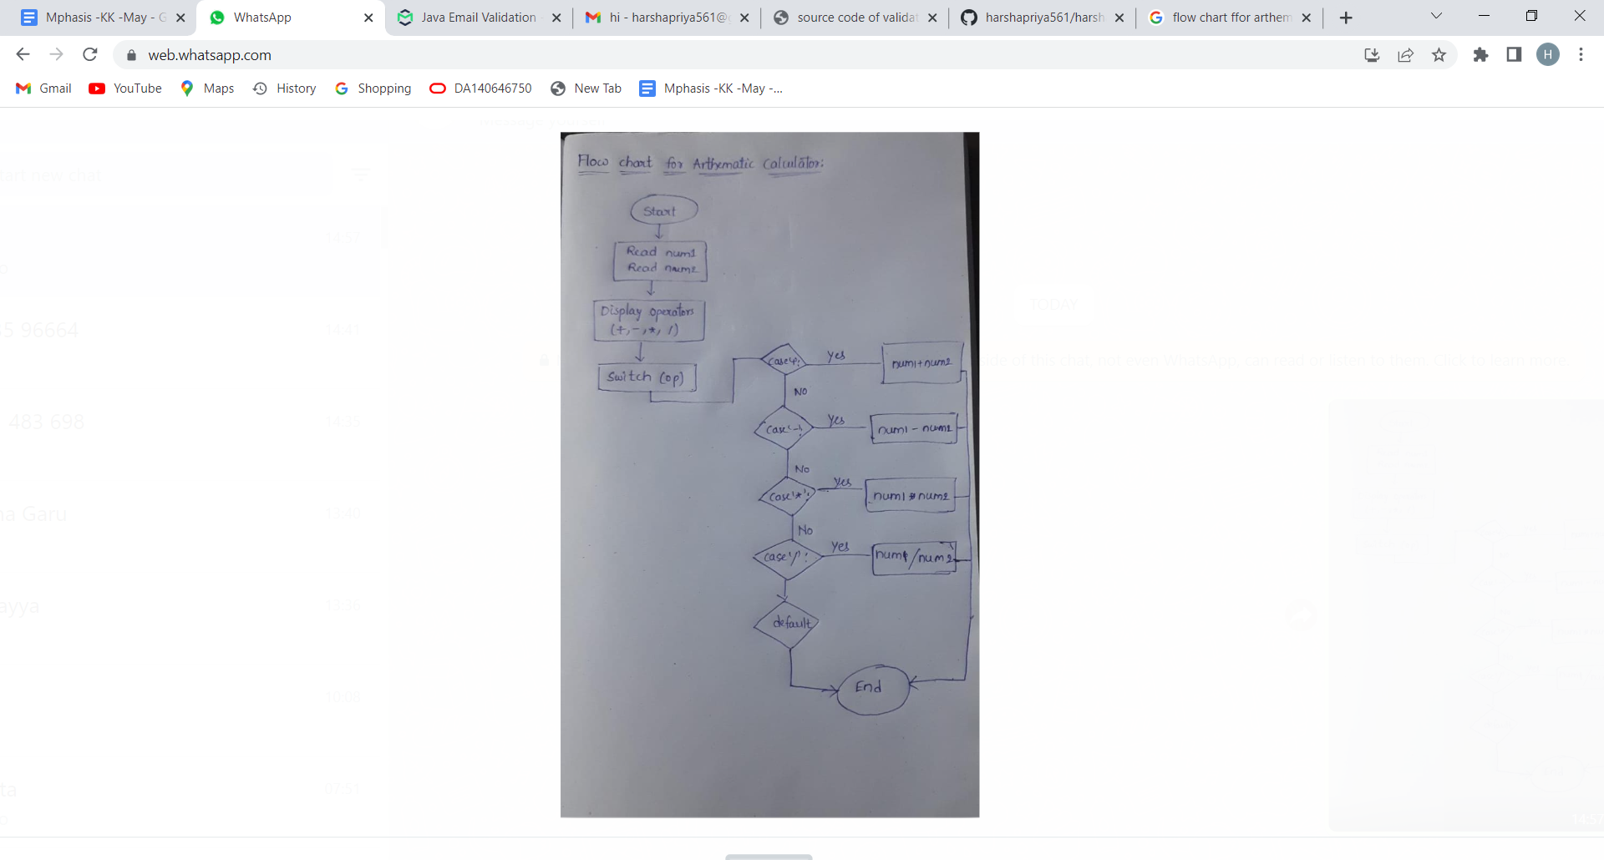

**Code:**

**package** arthematiccalculator;

**import** java.util.Scanner;

**public** **class** Calculator {

**public** **static** **void** main(String[] args) {

// **TODO** Auto-generated method stub

**double** num1;

**double** num2;

**double** ans;

**char** op;

Scanner sc = **new** Scanner(System.***in***);

System.***out***.print("Enter two numbers: ");

num1 = sc.nextDouble();

num2 = sc.nextDouble();

System.***out***.print("\nEnter an operator (+, -, *, /): ");

op = sc.next().charAt(0);

**switch**(op) {

**case** '+': ans = num1 + num2;

**break**;

**case** '-': ans = num1 - num2;

**break**;

**case** '*': ans = num1 * num2;

**break**;

**case** '/': ans = num1 / num2;

**break**;

**default**: System.***out***.printf("Invalid operator");

**return**;

}

System.***out***.print("The output is:");

System.***out***.printf(num1 + " " + op + " " + num2 + " = " + ans);

}

}

**Output :**

**1)**

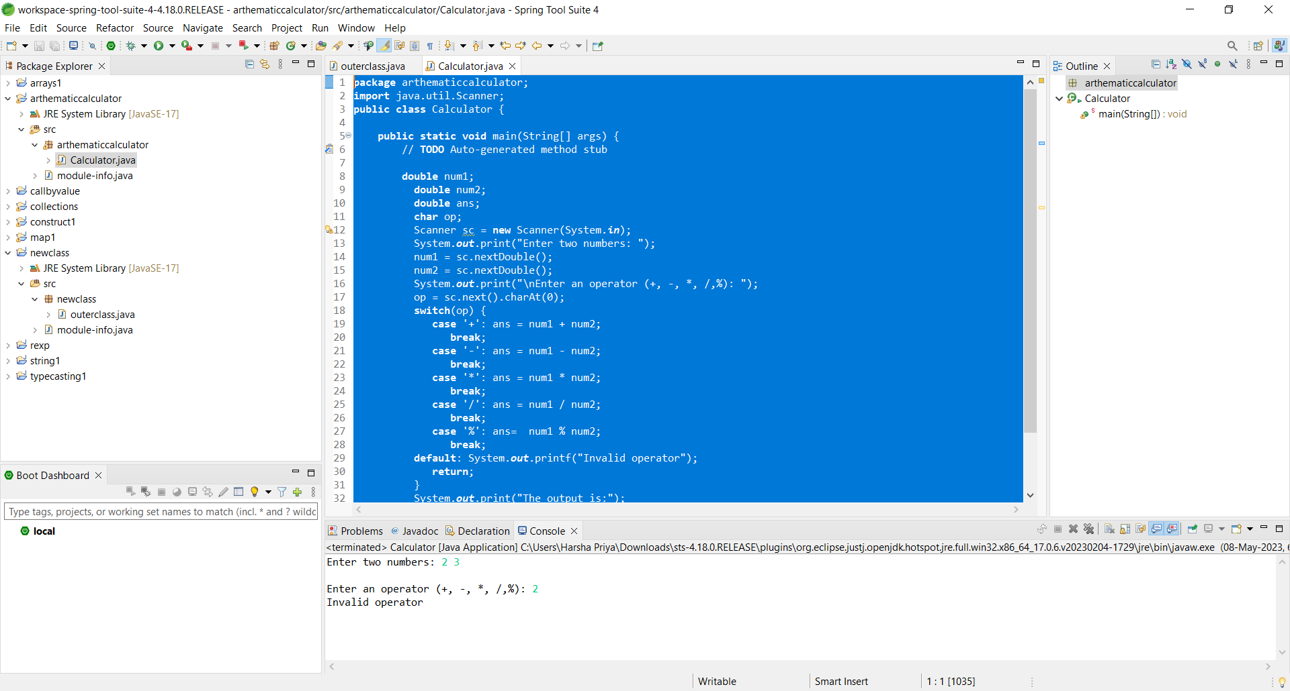

**2)**

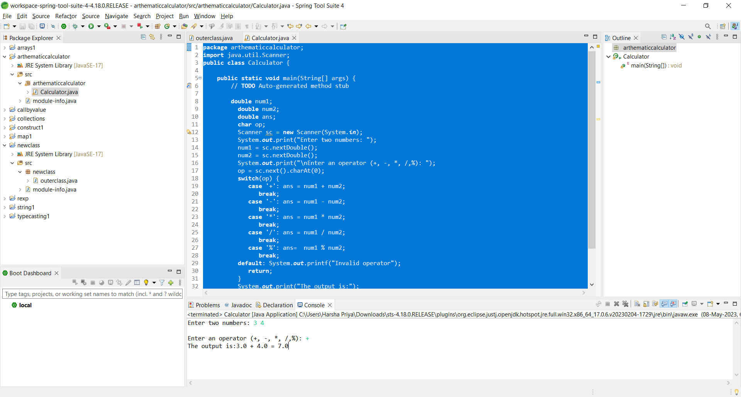

**3)**

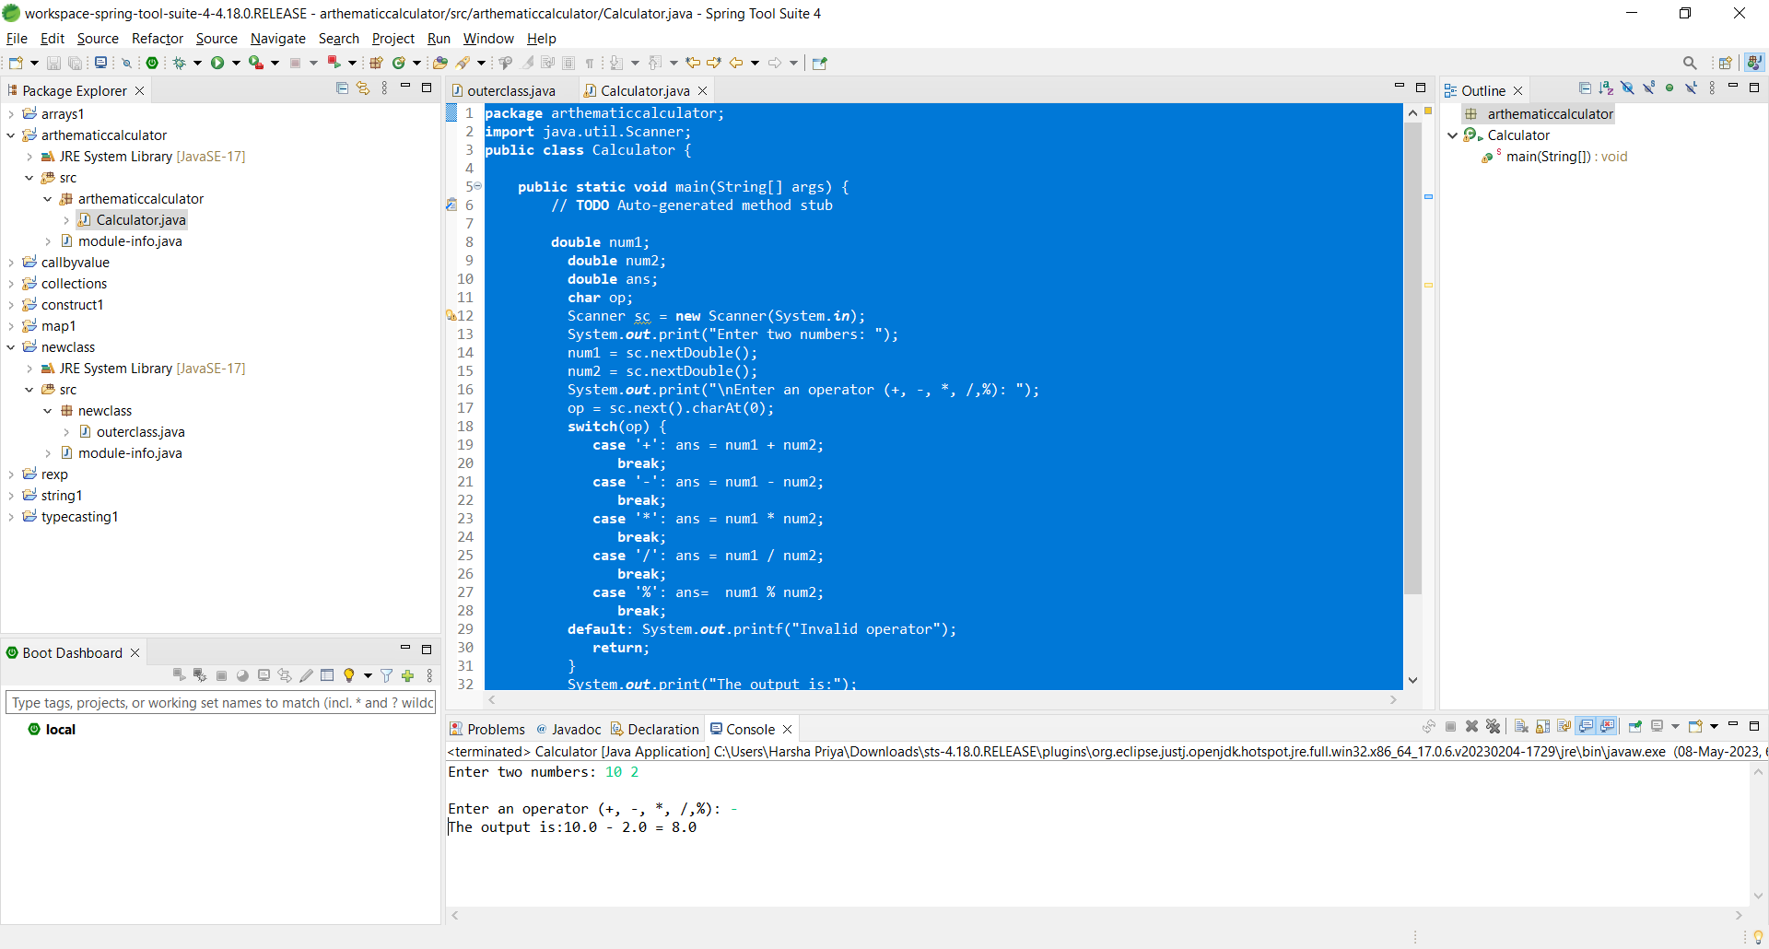

**4)**

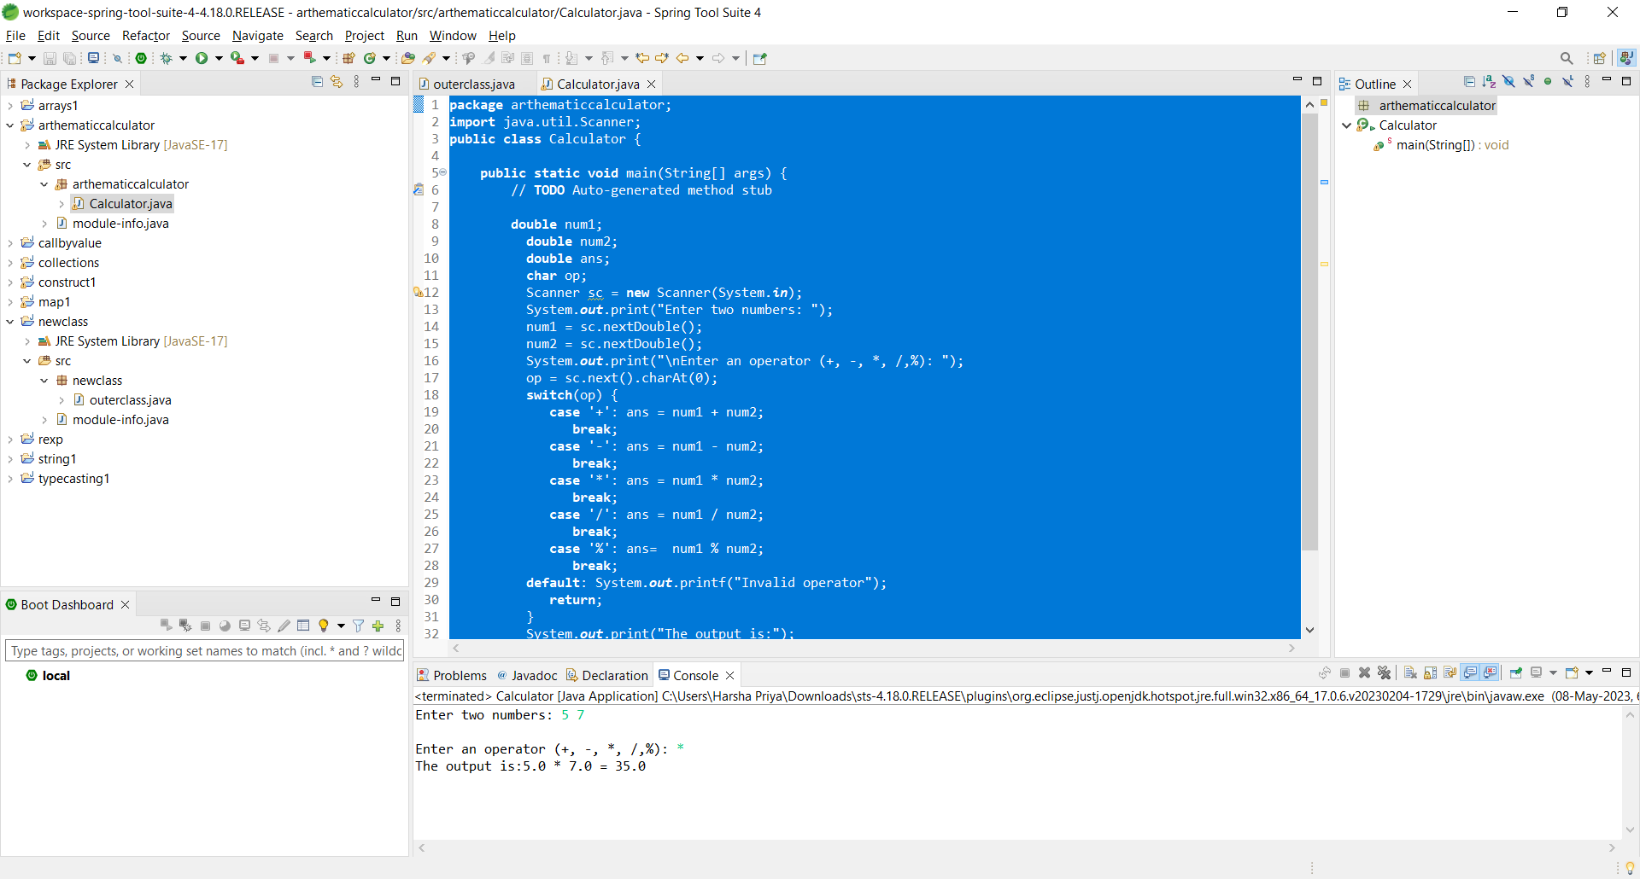

**5)**

